|  |  |  |
| --- | --- | --- |
| LHC- - - 1999-09-22 | | |
| TECHNICAL NOTE | | |
| Specification of the new COLDEX data acquisition User Interface | | |
| **Abstract:**  The present document specifies the User Interface envisaged for the upgrade of the COLDEX Data Acquisition System mainly based on TCP/IP connections in LabVIEW. | | |
| Prepared by :  R. Salemme  [roberto.salemme@cern.ch](mailto:roberto.salemme@cern.ch) | Checked by : | Approved by : |

|  |  |  |  |  |
| --- | --- | --- | --- | --- |
| Modification history | | | | |
| Rev. No. | Date | Pages | Description | |
| 0.1 | 22/07/2015 | All | | Document created |
|  |  |  | |  |

Contents

1. CONTEXT 4

2. DATA ACquisition Architecture 4

3. USER INTERFACE 5

3.1 structure 5

3.2 DEVICE Configuration panel 6

3.3 SYSTEM panel 7

3.4 EXPERIMENTAL DATA VISUALIZATION panel 7

3.5 RGAs panel 8

3.6 INSTRUMENTS VISUALIZATION panel 9

3.7 ACCELERATOR panel 10

3.8 CalCULATIONS panel 11

3.9 special data PLOT panel 12

4. TIMING 12

5. DATA STORAGE 12

6. COMMON FEATURES 14

# CONTEXT

COLDEX is an experiment of the TE-VSC group installed in the Super Proton Synchrotron (SPS) which mimics a LHC type cryogenic vacuum system.

In the framework of the High Luminosity upgrade of the LHC (HL-LHC project), COLDEX has been recommissioned in 2014 in order to validate carbon coatings performances at cryogenic temperature with LHC type beams. To achieve this mission, a data acquisition system is needed to retrieve and store information from the different experiment’s systems (vacuum, cryogenics, controls, safety) and perform specific calculations.

A new data acquisition framework based on direct communication with the experiment’s PLCs has been proposed. The communication protocol is based both on a novel open source Simatic S7 data exchange package over TCP/IP and subscription to data published on CERN Middleware (CMW). The conception of a new User Interface (UI) is therefore envisaged. The scope of the new UI is to organise the devices configuration and display the experiment data online, following the specific needs of the operator. In some cases, the UI lets the operator command and control specific instruments, which have not been integrated into a SCADA application due to lack of interface/drivers.

# DATA ACquisition Architecture

The current COLDEX Data Acquisition System architecture is mainly based on serial communication with the experiment devices controllers and is centralized on two desktop PC. The current architecture is shown in Figure 1.

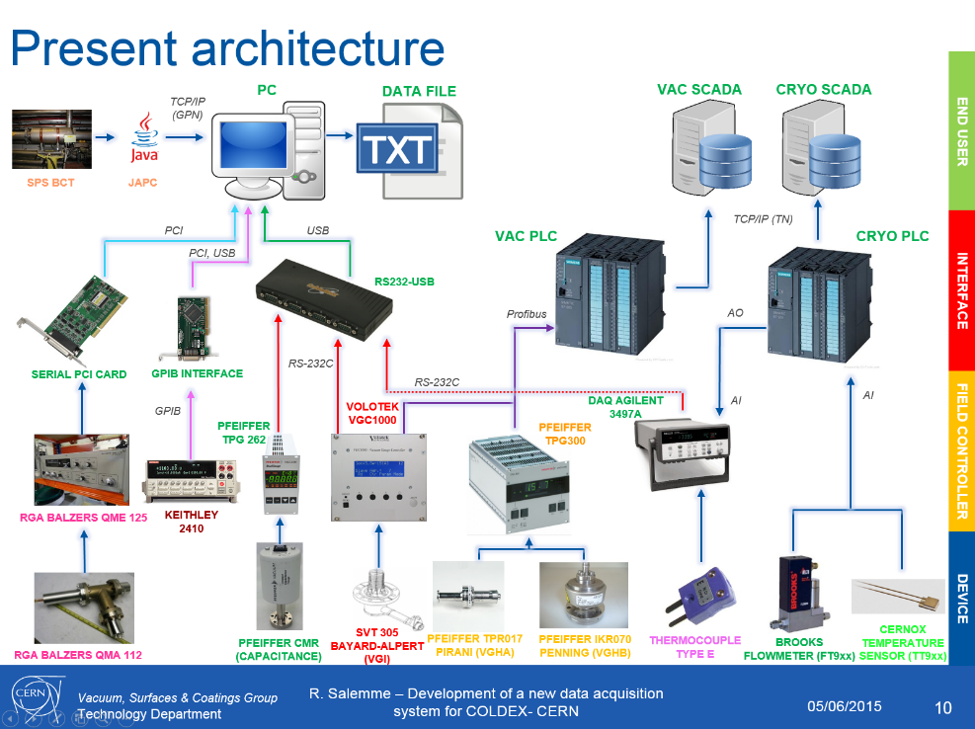

**Figure 1** —The COLDEX experiment present data acquisition architecture.

The development of a new data acquisition architecture is based, wherever applicable, on TCP/IP communication with the different PLCs belonging to the vacuum, cryogenic, and COLDEX system:

* **VAC PLC**: data belonging to vacuum devices (Pirani, Penning, Bayard-Alpert gauges, solenoids power supplies, sector valves positions, pumps status) is retrieved via subscription to the variables published on CERN Middleware (CMW).
* **CRYO PLC**: data belonging to cryogenic devices (pressures, levels, temperatures, valve positions, heaters, flows, pumps status) is retrieved via polling the CRYO PLC to download the specific DataBlock (DB) containing those variables.
* **COLDEX PLC:** data belonging to COLDEX ancillary devices (motors positions, thermocouple temperatures, and other AI signals) is retrieved via polling the COLDEX dedicated PLC to download the specific DataBlock (DB) containing those variables.

Some device variable is still not retrievable by a PLC, e.g. the RGAs, the capacitance gauges, the Keithley electrometers. On top of that, the RGAs and the Keithley electrometers required control besides data acquisition. This has to be correctly translated into the UI.

An overview of the new envisaged COLDEX Data Acquisition system architecture is available in Figure 2.

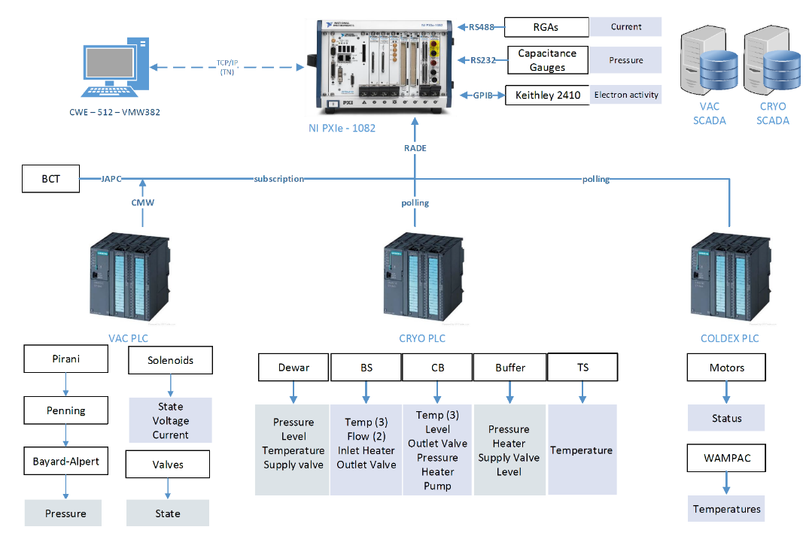

**Figure 2** —The COLDEX experiment proposed new data acquisition architecture.

# USER INTERFACE

## structure

The User Interface shall be structured to be contained in a single 1920x1200 display.

Given the big amount of information to be displayed, a tabular structure is envisaged.

A categorization based on the relevance of the information and the necessity of simultaneous display to the operator is done in the following sections.

The tabular structure obliges, however, the operator to swap between the tabs to monitor the information belonging to different categories. The possibility to organise the information on multiple windows (and therefore on multiple displays), e.g. transferring, on-line, a tab into a specific window, would be therefore desirable.

## DEVICE Configuration panel

The first panel should be devoted to the Device Configuration.

In the first part of this panel the operator sets the **experimental data** he wants to acquire and possibly store by **TCP/IP** or **RS232** and more specifically:

* sets the variable name (e.g. VGI_1, VHGB_41757, WM_T1, TT905_CR, CAP_1-1100);
* its unit (e.g. mbar, ◦C, K);
* the variable source (CMW, JAPC, PLC, RS232);
* the acquisition rate (nominally 1 Hz for all the variables);
* following the selection of the variable source, the required variable “coordinates” are adapted to the source (i.e. the class/property for CMW variables, the DB/address for PLC, the COM port/address for RS-232, etc.): the operator then fills the requested information;
* a flag for displaying the variable in the Data Visualization panel;
* a flag for storing the variable in the datafile.

The **Residual Gas Analysers** (RGA1, RGA2) are declared in a second part of this panel. They require **analog communication**. The settings here are suited to properties needed to establish communication to them, which are currently unknown.

**Instruments** which require command, control and data acquisition via **serial** (RS232, GPIB) **communication** (like Keithley 2400 sourcemeters) are declared in a third part of this panel:

* instrument name (e.g. K2410_1, K2410_2);
* the controller/instrument type (e.g. K2410);
* the communication protocol (RS-232, GPIB);
* the acquisition rate (nominally 5 Hz for the Keithley sourcemeters);
* following the selection of the controller source, the requested “coordinates” are adapted to the source (i.e. the COM port for RS-232, the address for GPIB, etc.): the operator then fills the required information.

The **accelerator** (SPS) devices are declared in a fourth part of this panel. They require **TCP/IP** communication through CMW/JAPC:

* variable name (e.g. SPS_BEAM_INT);
* its unit (e.g. p);
* the variable source (e.g. JAPC);
* the acquisition rate (nominally 10 Hz);
* following the selection of the variable source, the requested “coordinates” are adapted to the source (i.e. the class/property for JAPC variables, etc.): the operator then fills the required information;

At the bottom of this page, the following sections shall be envisaged:

* a section where the datafiles main path is entered and shown. Please refer to Section 3.6 for further information regarding the datafiles structure and properties.
* a section to store and load configuration files.

## SYSTEM panel

This panel shows to the operator the elements of the experiment status relevant to the physics of it. It should be clear that this panel is not meant to be a SCADA, which is in principle available through the standard dedicated vacuum (SPS/TS4) and cryogenics (CRYOEXP/COCA) SCADA applications.

For sake of clearness, however, the information could be arranged in a hybrid synoptic scheme, representative of the vacuum/cryogenic/movement systems.

Example of information relevant to the experiment physics is: COLDEX position OUT/IN, sector valves open/closed, injection line gate valve open/closed, SPS East Extraction bump inhibit command sent/acknowledged, etc.

This panel is not likely to evolve and doesn’t need an operator personalization, so it is structured on the .vi level and no settings are available on-line.

A flag/button should be available for storing the Boolean information behind these status in the same datafile of the experimental data (additional columns, same acquisition time). Information is saved as 0/1. Strings like *on/off* or *open/closed* are not desirable. The meaning of 0/1 is instead stated in the header of the column.

## EXPERIMENTAL DATA VISUALIZATION panel

This panel shows to the operator the temporal trend of the experimental data acquired by the data acquisition system and flagged for display in the Device Configuration panel, first part.

On top of this panel, a control integer lets the user select how many multi-signal graphs he wants to display simultaneously. The user then arranges the variables in the different multi-signal graphs (drag and drop, or drop down menu).

Example:

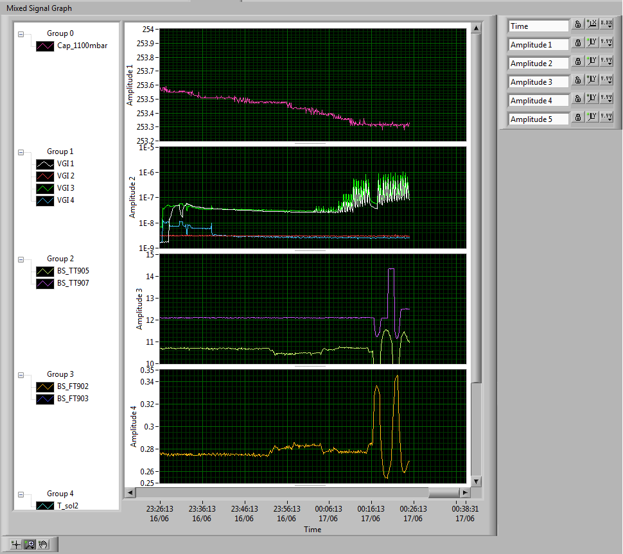

A *store acquisition* (default: yes) and *start/stop acquisition* button functionality should be available.

There are two sections which are requested in this panel:

1. a section where data is numerically shown and updated at each UI loop;
2. a section where data is shown in multi-signal graphs *time vs. value* and updated at each UI loop.

Sections 1 and 2 can possibly be merged if a LabVIEW suitable plotting environment exists.

## RGAs panel

The RGAs require command and control on top of data visualization. COLDEX has installed two Balzers-type RGAs and the number of these instruments is not likely to change, so the UI can be fit to display only two instruments (e.g. upper part: RGA1; lower part: RGA2). An existing .vi is available to command, control, acquire and show the Balzers-type RGAs (see *Coldex-RGA-Vac.lvproj*).

The envisaged structure of the panel is:

* On the left part, the RGA settings are displayed (mode, SEM voltage, First Mass, Width, Amplification). An example below (in this module, the mode *spectrum* means that the RGA is used as a mass *spectrometer*):

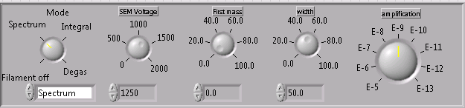

* A toggle lets the user select if he wants to use the RGA for a spectrum (“picture” displaying all the masses range) or a masses follow-up (selected masses “time trend”).
  + in case of a spectrum mode, the user has a button to launch the spectrum (following the RGA setting specified before) and another to store the datapoints once performed.
  + in case of a follow-masses mode, the user can insert the masses a.m.u. he wants to follow-up (nominally 2, 5, 12, 14, 15, 16, 17, 18, 28, 32, 44), the window and the time interval (time left between acquisitions: the lowest possible). Then he has a button to decide to store the follow-masses (default: yes) and a button to launch the continuous acquisition. An example of setting for Follow-masses mode below:

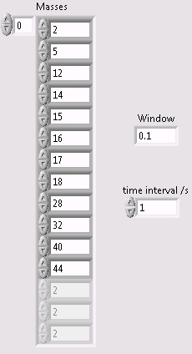

* According to the toggle, the screen is adapted, on the right, to show either a Spectrum graph, or a Follow-masses graph. In case of Follow-masses, the select masses a.m.u. are shown and their respective currents displayed and updated at each UI acquisition loop:

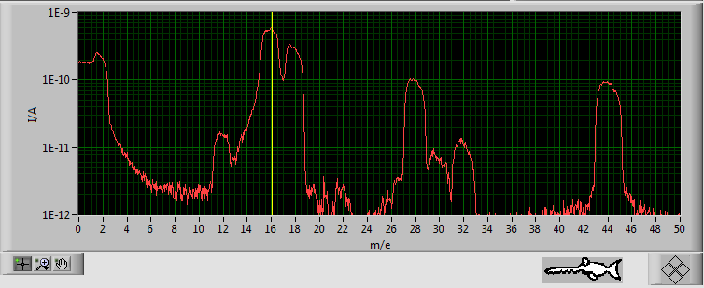 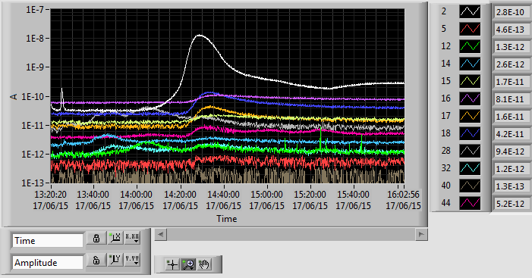

## INSTRUMENTS VISUALIZATION panel

This panel is dedicated to instruments, other than the RGAs, where command, control and data acquisition is required. At this stage, only the Keithley 2410 GPIB sourcemeters fall in this case. Instruments are defined in the third part of the Device Configuration panel.

**K2410_1 and K2410_2**

Two Keithley 2410 are currently adopted in the COLDEX experiment. As a RGA, the Keithley sourcemeter can be operated in “Voltage sweep” mode or “DC follow-up” mode. Existing .vi are available to command, control, acquire and show this instrument in the sweep (*2400 swV Linear Stair with DCV – gpib.vi*) or follow-up (*K2410_MeasDC.vi*) mode.

* In *V sweep mode*, the voltage sourced by the instrument is ramped following different voltage points and delays. An example of the different settings to be defined to set up the voltage ramp points is available below:

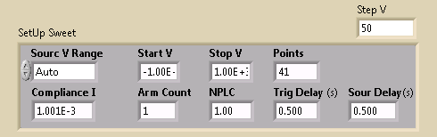

Following a voltage sweep, corresponding current sourced or sinked for each voltage point should be visible in a tabular manner (time, voltage, current), or on a V-I plot (toogle).

Example:



After a sweep, the user can choose to save the data points in a datafile.

* in *DC follow-up mode*, the source Voltage level is fixed by the user as well as the current compliance (max sourced or sinked current). The user has a button to decide to store the DC follow-up (default: yes) and to launch the continuous acquisition. A numerical (indicator) and time trend (graph) of the current (A) should be shown.

Example:



Superimposed to the current follow-up graph, the DC voltage bias adopted is desirably shown (the current sourced or sunk depend on the voltage applied).

This panel could be structured similarly to the RGA panel.

## ACCELERATOR panel

In this panel, the accelerator diagnostics variables relevant to the COLDEX operation and defined in the fourth part of the Device Configuration panel are displayed. Currently, the SPS beam intensity (n. of protons circulating) is retrieved by the SPS.BCT.31832 (10 Hz) via polling through JAPC. An existing .vi is available: *SPS_beam_intensity_v.2.vi*. Subscription instead of polling is desirable.

Following declaration in the Device Configuration Panel, the variable is plotted in this panel, either as a chart (follow-up) or as a graph (history), by a toggle. Example:

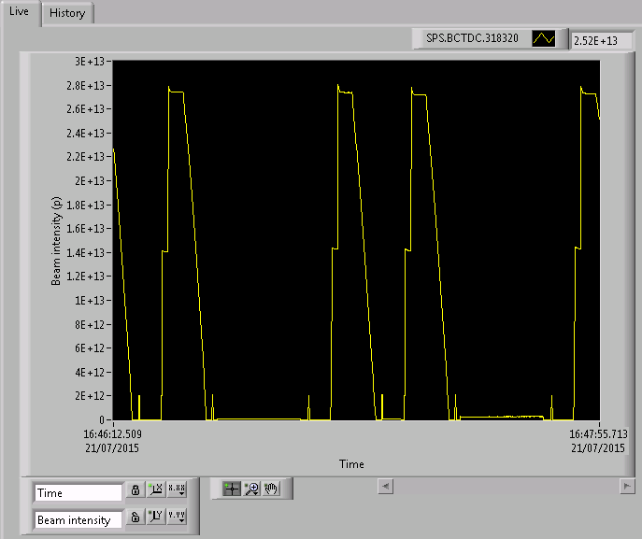 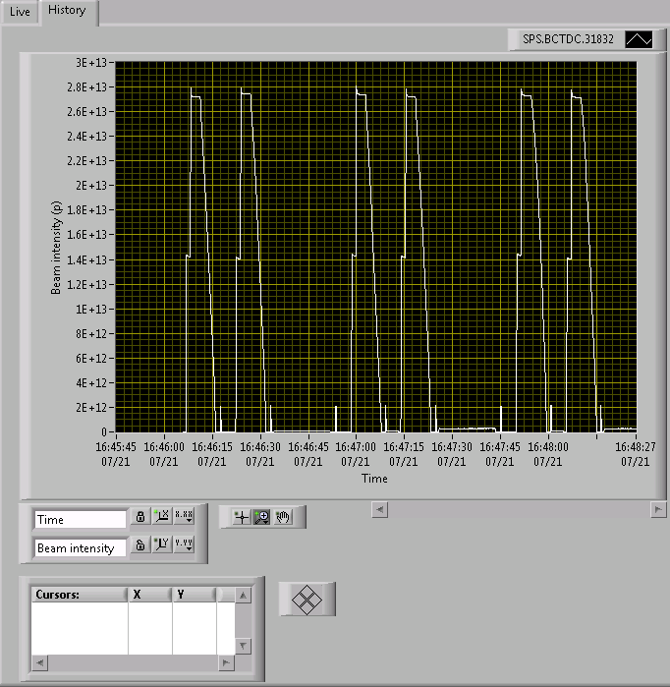

A *store acquisition* (default: yes) and *start/stop acquisition* button functionality should be available.

## CalCULATIONS panel

In this panel, the user can select specific calculations he wants to perform on the basis of the online experimental data observed. The calculation has to be prepared beforehand in a sub .vi, and the user selects between a list of possible calculations to be performed. Once the calculation is selected, the screen automatically adapts and shows, on the left, the required input parameters. On the right, a numeric indicator shows the calculated result at each UI loop, and graph shows its time trend.

A *store calculation* (default: yes) button is provided, as well as *start/stop calculation* button.

**BS dissipated power**

INPUTs: BS_T_inlet = TT905CR (K)

BS_T_outlet = TT907CR (K)

BS_flow = FT902CR (g/s)

CALCULATION:

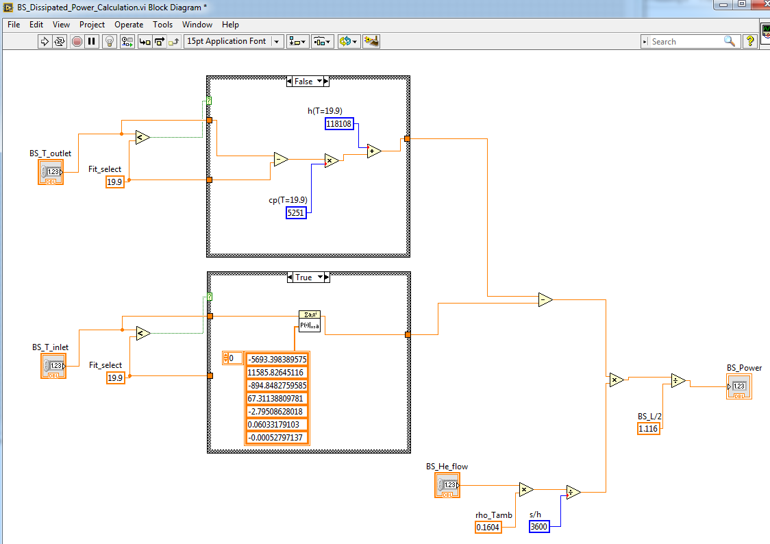

## special data PLOT panel

This panel is a multipurpose data plots panel where selected variables are plotted one against the other. In general, all variables possibly in acquisition should selectable in this panel. Time should be a selectable variable.

Examples:

TT905CR_vs_VGI2

TT905CR_vs_RGA1_amu2

SPS.BCT.31832/IntensityNow_vs_K2410_1_I

A control integer lets the user select how many plots he wants to display simultaneously. The user selects for each plot the *x* and *y* variables from a drop down menu. Data is plot on the graph as datapoints (no lines). A reset button allows the user to reset the graph (typical action after an undesired transient). A save button allows the user to save the datapoints in a specific datafile.

# TIMING

Two kind of data are to be acquired, visualized and stored:

* **Continuous data**: data is continuously acquired in the experimental data panel, by the RGAs in follow-masses, by the Keithley instruments in DC follow-up, by the Accelerator devices, by the Calculation mode.
* **Batch data**: data is quickly acquired and plotted in a batch-mode in the RGAs spectrum mode, by the Keithley instruments in sweep mode. In the Special Data Plot data is acquired and shown continuously, but can be saved as a batch. The user chooses to store this data in a datafile by buttons in the relevant panels.

Given the difference in the data flow, the following timing convention is proposed:

* Continuous data is stored on the basis of a same master clock, defined by the Main.vi. Data is sorted through its univocal acquisition timestamp. Experimental data retrieved by PLC, CMW, JAPC and possibly RS232 (capacitance gauge case) is displayed and written at 1Hz. Data from the RGA follow-masses is stored at the end of each measurement loop (time period: defined by the number of the masses; up to 6 seconds for 12 masses) and released when a new time entry is available. Data retrieved by the Keithley DC follow-up and by the machine instruments (5 Hz, 10 Hz) is sampled so that it falls periodically synchronized to the master clock.
* Batch data is stored independently, at the end of each specific loop and with no synchronization with other processes. The time relative to the beginning and the end of the batch data acquisition is displayed, and stored in the datafiles.

# DATA STORAGE

Data flagged in the Device Configuration panel for the Experimental Data or chosen to be stored in each relevant panel (RGA, Instruments, Accelerator, Calculations, and Special Data Plot) is stored by the UI in a ASCII files. The proposed extension is *.dat*. The datafiles should be released at each UI loop in order to be able to open it with an external visualizer/editor in read-only mode and check the correct storage of data.

Given the variety of data, the presence of many datafiles is envisaged.

The main datafiles path shall be prompted when launching the Main.VI. The UI proposes a directory name header formed by the date/time in YYYYMMDD_HHMMSS format, the user fills up the directory name with a short comment describing the run.

A name header, formed by the date/time in YYYYMMDD_HHMMSS format is always adopted in each datafile. The datafile name is then followed by a “_”. The datafile name follows with the device, property or mode of acquisition, and the notation of the variables displayed, e.g. “*x-variable*_vs_*y-variable*”. The datafile name is then followed by a “_”. Each time a *start acquisition* is requested, the operator is prompted to conclude by a comment, significant for the experimental run to be held.

A proposed directory structure follows as an example:

*20150721_161620_Test_run/*

*/experimental*

*/20150721_161620_COLDEX.dat*

*/RGA*

*/RGA1*

*/spectra*

*/20150721_161623_RGA1_spectrum_Before_injection.dat*

*/FM*

*/20150721_161822_RGA1_FM_Follow-up_Test_run.dat*

*/RGA2*

*/spectra*

*/20150721_161742_RGA2_spectrum_Before_injection.dat*

*/FM*

*/20150721_161828_RGA2_fm_Follow-up_Test_run.dat*

*/Instruments*

*/K2410_1*

*/sweeps*

*/20150721_161623_K2410_1_sweep_Before_injection.dat*

*/DC_follow_up*

*/20150721_161854_ K2410_1_DC_Follow-up_Test_run.dat*

*/K2410_2*

*/sweeps*

*/20150721_161653_K2410_2_sweep_Before_injection.dat*

*/DC_follow_up*

*/20150721_161934_ K2410_2_DC_Follow-up_Test_run.dat*

*/machine*

*/SPS.BCT.31832*

*/20150721_162011_ SPS.BCT.31832_IntensityNow_Follow-up_Test_run.dat*

*/special_data_plot*

*/TT905CR_vs_VGI2*

*/20150721_162513_TT905CR_vs_VGI2_Induced warm-up.dat*

*/20150721_161620_Test_run_log.txt*

The datafiles structure is organised in TAB separated columns:

* The first column is imperatively the acquisition time in UNIX timestamp format (seconds.milliseconds). Its header is “acqUNIXTimestamp”.
* The second column is imperatively the acquisition time in YYYYMMDD_HHMMSS.mmm format. Its header is “acqDateTimestamp”.
* The subsequent columns follow the variable order. The header of each column contains has the following format: “*variable_name* (*unit*)”.
* Last column is left for online comments. Its header is “*Comment*”.

The data values format (numeric/scientific, number of digits) follows the one chosen and adopted for visualization in the specific panels.

# COMMON FEATURES

Along the tabs, the following buttons/functionality should be always displayed by the UI. Preferably in the display corners:

* a print-screen button. Once pushed, a pop-up windows proposes the path to store the picture. The filename begins with acquisition time in YYYYMMDD_HHMMSS format, then follows with an “_”, and ends with an operator comment describing the snapshot. The default extension for the picture file is .png.

Example: “20150720_145022_VVSB_41753_opened.png”.

* a Comments box, where a long string can be input by the operator to build-up a logbook. Comments are saved in 20150721_161620_Test_run_log.txt, preceded by the timestamps, once a *write* button is triggered.
* a .vi STOP command.

Preferably next to each graph:

* each graph should be equipped with LabVIEW tools to navigate into or adjust a graph:

 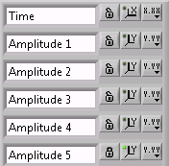

* a cursor should be available next to each graph. Due to the high number of variables, probably the cursor relative table containing the values corresponding to the cursor position could be displayed in a pop-up (*always on-top*) window.